[E143] WIFI module

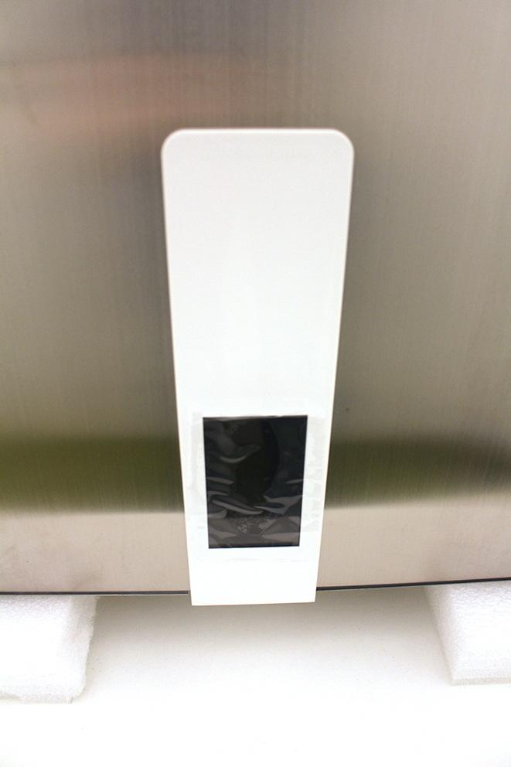

Unscrew the front panel fixing screws.

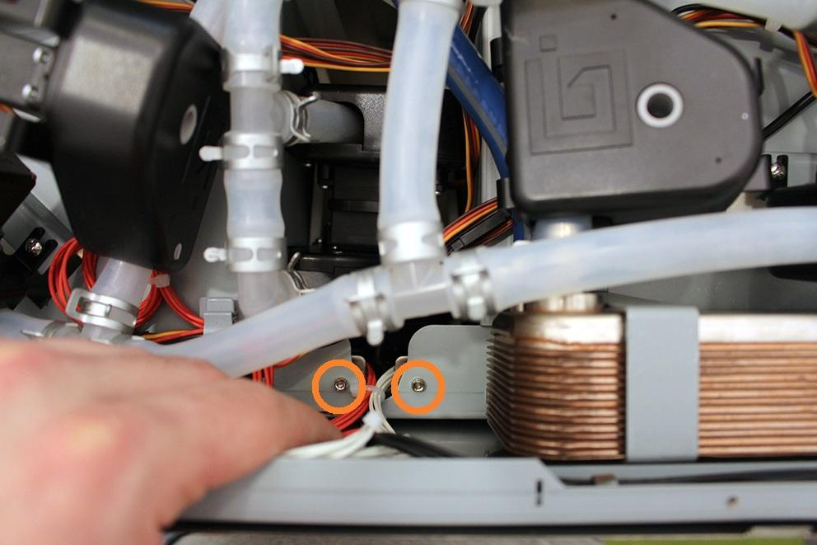

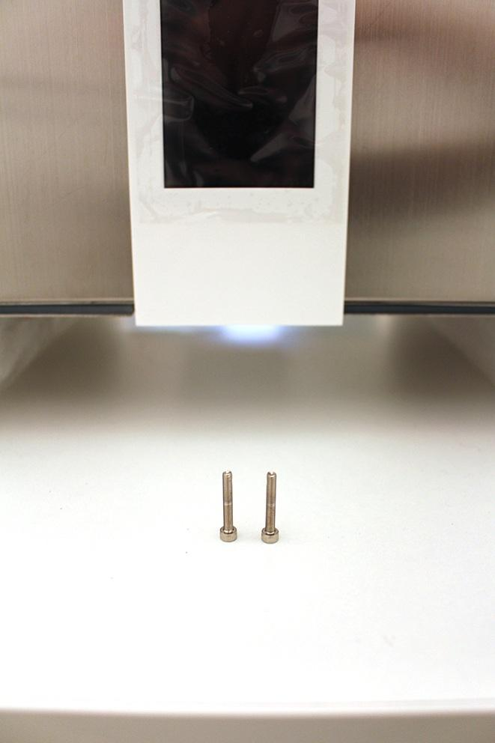

Push down the front panel to pop it out.

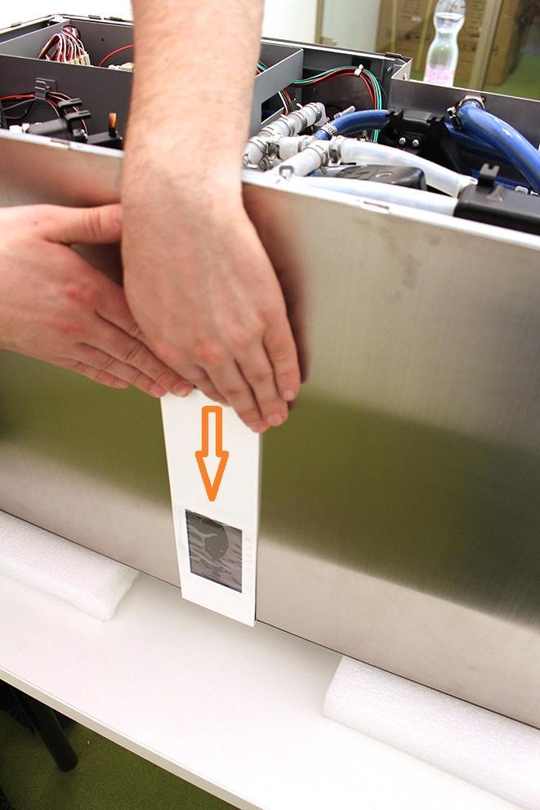

Disconnect the indicated plugs from the front panel.

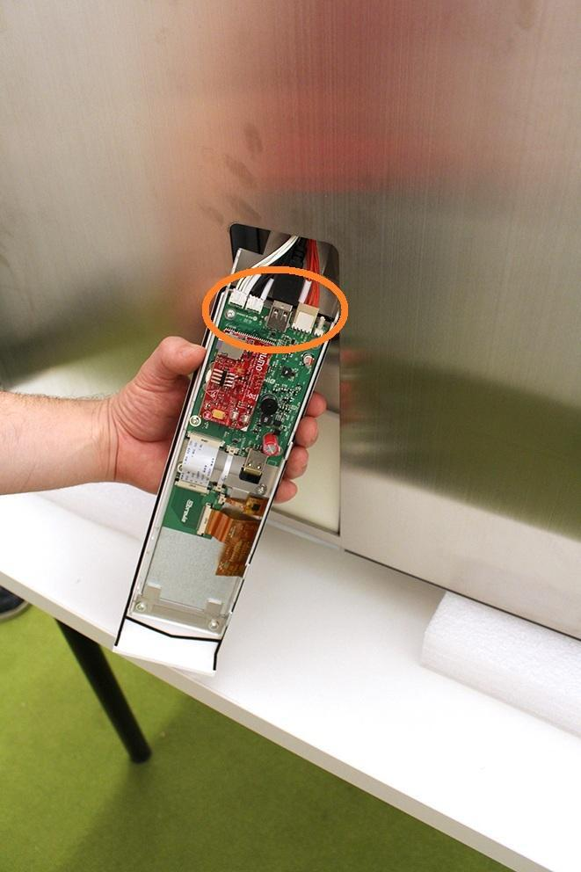

Now you can remove the front panel unit.

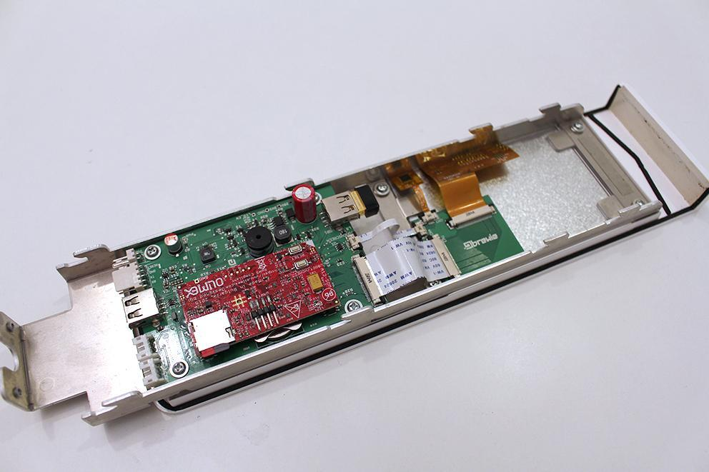

Pull off the WIFI unit.

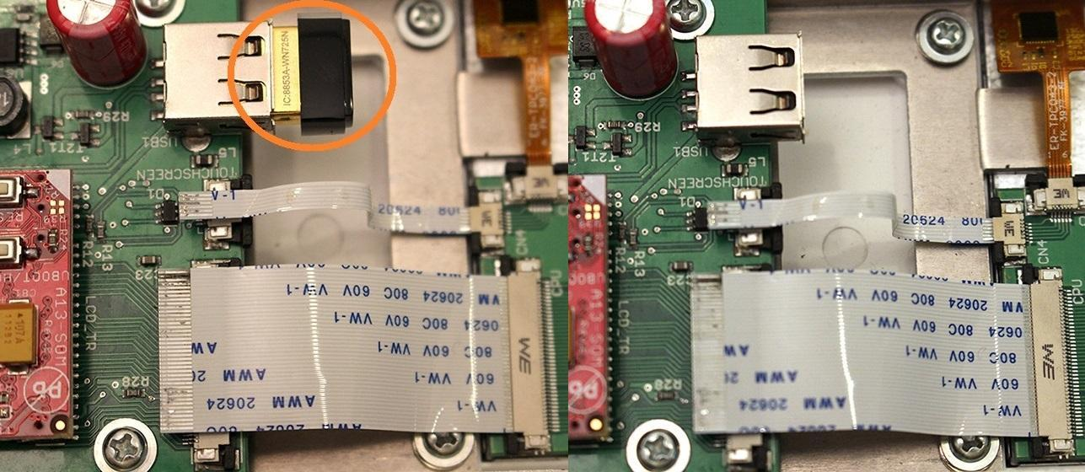

Now you can replace the wifi unit.

Reassemble consists of the same steps in reverse.